

**Forest Fire Simulation Model**

**Cellular Automata Approach and Analysis**

**Bradley Ochola 670346**

**Zakariya Muhumed 668596**

**2024-29-7**

**Contents**

1. Introduction
2. Methodology
   1. Model Overview
   2. Forest Grid Creation
   3. Fire Spread Rules
   4. Environmental Factors

4.Visualisation and simulation

5.Results and Discussion

* 1. Simulation Observations
  2. Model Performance
  3. Limitations
  4. Future Improvements

6Conclusion and Recommendations

7.References

**1. Introduction**

Forest fires pose significant ecological, economic, and social challenges.

Understanding the dynamics of forest fires is crucial for developing effective mitigation strategies and improving prediction accuracy.

One approach to simulate and analyse fire spread patterns is Cellular Automata (CA), a computational method that represents individual cells (trees) and their interactions within a grid.

**Cellular Automata (CA)**

CA is a discrete model consisting of a grid of cells, each of which can be in one of a finite number of states.

The state of a cell at any given time depends on a set of rules that consider the states of neighbouring cells (Wolfram, 1983).

**Forest Fire Dynamics**

Forest fire dynamics are influenced by various factors, including vegetation type, weather conditions, and topography. Wind direction, in particular, plays a critical role in determining the speed and direction of fire spread (Sullivan, 2009).

This report describes the development and implementation of a CA model to simulate forest fire spread.

The model considers factors such as tree health status, flammability, and wind direction, providing insights into fire behaviour and potential applications for fire management.

**2. Methodology**

**Model Overview**

The CA model developed in this study simulates a forest as a grid of cells (trees). Each cell is characterized by its health status, location, and flammability. The health status can be one of three states: healthy, burning, or burnt. The model updates the forest state in discrete time steps, considering the influence of neighbouring cells and wind direction on fire spread.

The simulation consists of the following key components:

1. Forest Grid Creation
2. Fire Spread Rules
3. Environmental Factors

**1a) Forest Grid Creation**

**Steps:**

* **Define the size and resolution of the forest grid**

The forest grid is a matrix where each cell represents a tree.

The size and resolution are determined by the number of rows and columns.

* For example, a grid of 100x100 cells can represent a 100x100 forest area.

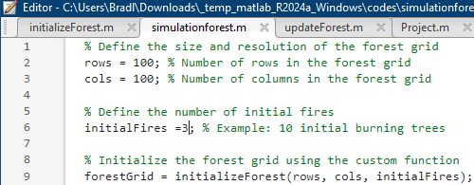

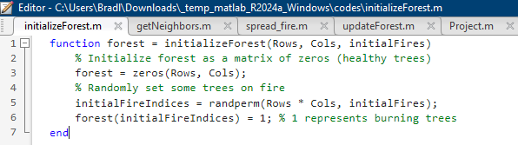

The forest grid is initialized with zeros, where each zero represents a healthy tree. A small number of trees are randomly set to burning the initialization ensures the presence of an initial fire source

The forest grid represents the forest area as a matrix where each cell can have one of three states: healthy (0), burning (1), or burnt (2).

The grid is initialized with a majority of healthy trees and a specified number of randomly placed initial fires.

**2. Fire Spread Rules**

**Steps:**

* **Implement rules for fire propagation based on the Moore neighbourhood**
* **A healthy tree can catch fire if a certain number of burning neighbours are present**
* **A burning tree transitions to burnt after a specific time step**

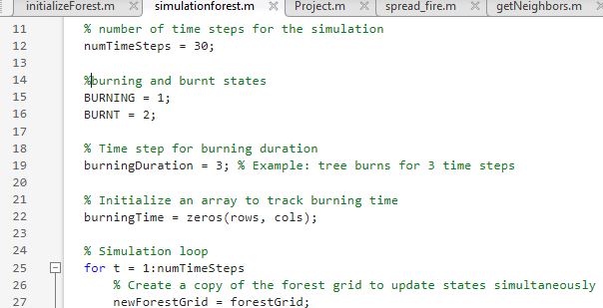

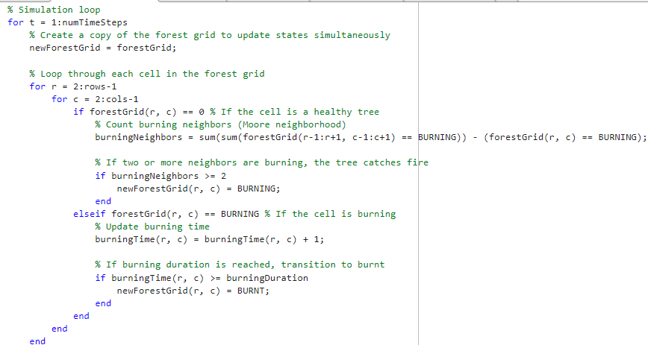

The fire spread is governed by the Moore neighbourhood, where each cell (tree) can interact with its eight surrounding neighbours. The rules for fire spread are:

* A healthy tree catches fire if two or more neighbouring trees are burning. This rule simulates the spread of fire from one tree to another.
* A burning tree transitions to burnt after a specified duration.This step ensures that once a tree has burned, it cannot catch fire again.

**3. Environmental Factors**

**Steps:**

* **Explore ways to integrate environmental factors like wind direction into the model**

Wind direction can be considered to simulate its effect on fire spread. The wind increases the likelihood of fire spreading in the downwind direction by modifying the fire propagation rules.

* **Wind could increase the probability of fire spread in the downwind direction**

The wind factor adjusts the probability of fire spread based on its direction. For example, if the wind is blowing east, the fire spread probability is higher for cells east of a burning tree.

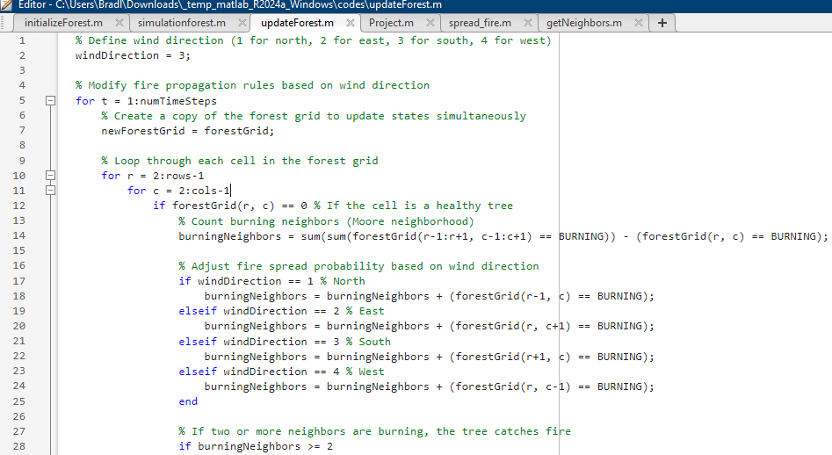

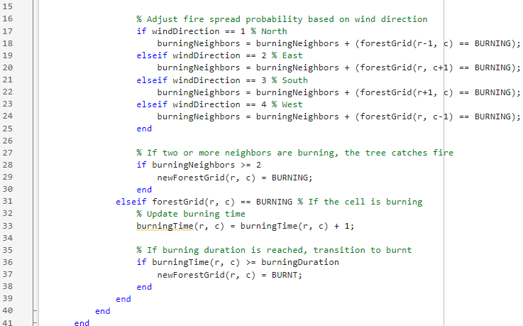

1. **Visualization**

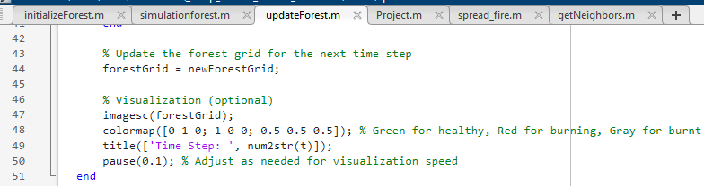

The imagesc function is used for visualization, with a colormap indicating healthy trees (green), burning trees (red), and burnt trees (grey).

The simulation runs for a specified number of time steps, updating and displaying the forest grid at each step.

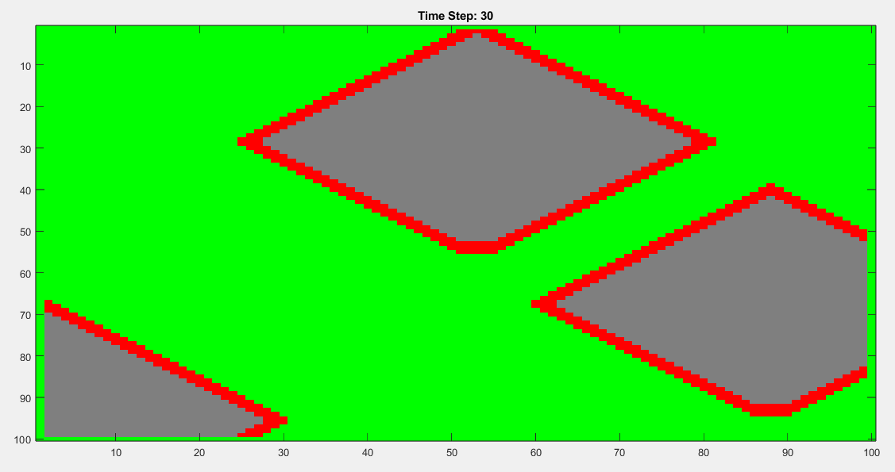

1. **Results**

**a) Simulation Observations**

The simulation of forest fire spread using the CA model reveals several key observations.

The spread of fire is highly dependent on the density of burning trees and the wind direction.

Areas with higher concentrations of burning trees exhibit faster and more extensive fire spread.

**b) Model Performance**

The CA model effectively captures the basic dynamics of forest fire spread.

The inclusion of flammability and wind direction enhances the realism of the simulation. However, the model's simplicity may limit its accuracy in representing complex fire behaviours observed in real-world scenarios.

**c) Limitations**

The CA model has several limitations, including:

* Simplified representation of fire dynamics.
* Lack of consideration for varying vegetation types and topography.
* Fixed flammability factor for all trees.

**d) Future Improvements**

Future improvements to the CA model could include:

* Incorporating varying vegetation types and topography.
* Implementing more sophisticated rules for fire spread based on environmental conditions.
* Introducing probabilistic elements to better simulate the stochastic nature of fire spread.

**4.Conclusion and recommendation**

The CA model provides a useful tool for simulating and understanding the spread of forest fires.

While the model captures essential dynamics, further enhancements are needed to improve its accuracy and applicability. Continued development and validation against real-world data will be crucial for advancing forest fire simulation models.

**5. References**

Bonabeau, E. (2002). Agent-based modelling: Methods and techniques for simulating human systems. *Proceedings of the National Academy of Sciences*, 99(Suppl 3), 7280-7287.

Sullivan, A. L. (2009). Wildland surface fire spread modelling, 1990-2007. *1: Physical and quasi-physical models*. International Journal of Wildland Fire, 18(4), 349-368.

Wolfram, S. (1983). Statistical mechanics of cellular automata. *Reviews of Modern Physics*, 55(3), 601.